
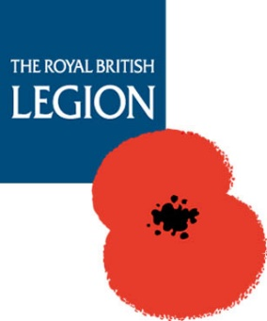
The British soldier in Afghanistan Ground Roots
Royal British Legion, Paris Branch, 28 Rue des Acacias, 75017 Paris
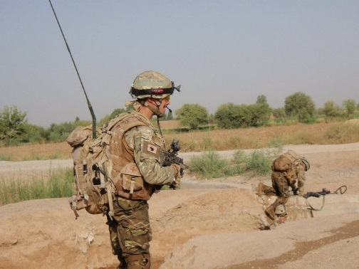
Tuesday 16th July, 1830hrs
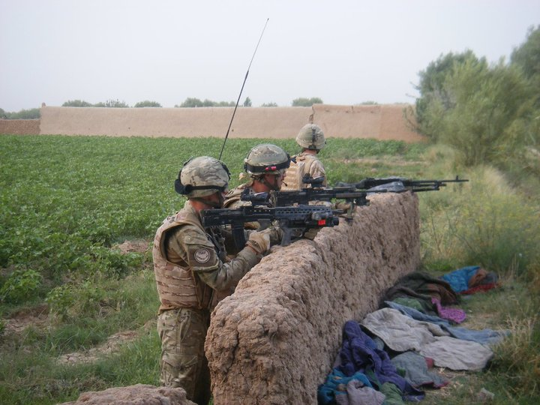
Captain Edouard Plunkett, Queens Royal Lancers (2012), was a Multiple Commander in Helmand Province, Afghanistan in 2010. He spearheaded a major offensive against the Taliban over a 7 month period, having also served in Iraq.
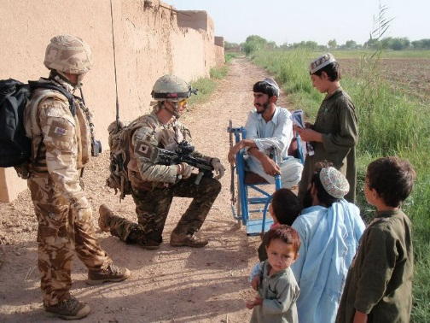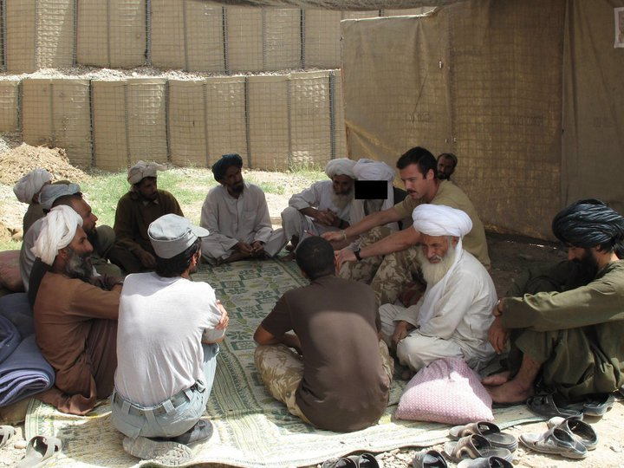
Edouard will give a basic account of life on the ground during the most kinetic period of operations in Helmand province since 2002 (HERRICK 12, April – November 2010).
Parfaitement bilingue Edouard sera ravi de répondre à vos questions en français.
12€ including snacks. Cash Bar

RSVP to: Mrs Joan Hicks, 6 rue des Petits Prés, 78810 FEUCHEROLLES
Tel: 01 30 54 33 06
Mob: 06 19 17 34 48

Net proceeds to the RBL Paris Branch General Fund

